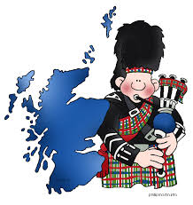 PONTELAND BOWLING CLUB
BURNS NIGHT SUPPER
Thursday 24 January 2019 at Ponteland Golf Club – 7 for 7.30pm
Address to the Haggis, Piper and Choice of Menu
Starters:- Haggis, Neeps and Tatties(with Whisky Gravy)
or Scotch Broth
Main Course:- Roast Beef and Trimmings or Scottish Salmon

Afters:- Cranachan (Raspberries, oats & cream)) or Apple Crumble
Coffee and Mints
Raffle: Any prizes would be welcome.
Price £19 per person – Tickets from GPC and Social Committee Members.
Bring Family, Friends, Neighbours etc. The more the merrier.
Don’t forget to wear an item of tartan or something Scottish. 